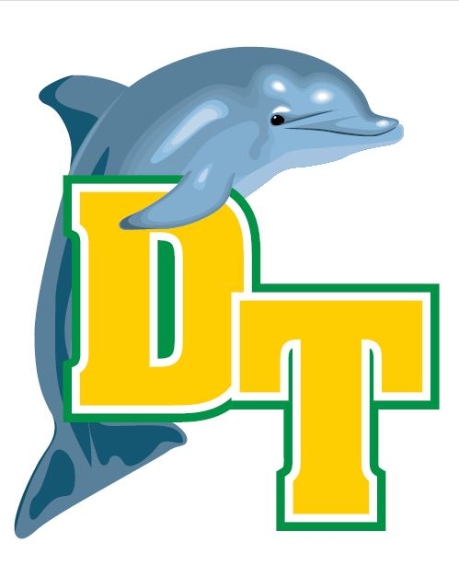

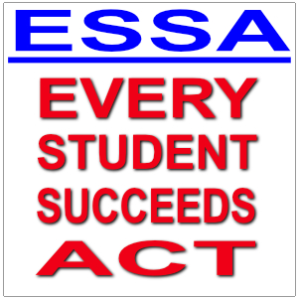
Parent’s Copy Provided:

Double Tree Elementary School
Family Engagement Plan
Every Student Succeeds Act
2023-2024 Family Engagement Plan
Revised 9/15, 9/16. 8/17, 9/18, 8/19, 9/30/22, 5/5/23

Parental involvement is an integral part of school success. Our Family Engagement Plan was jointly developed with our parents. At Double Tree we believe that an important triangle exists between school, home and community. It is our policy to treat parents, extended family and other community stakeholders with high levels of respect and inclusiveness. We regard our partnership with families and key community entities as a significant building block in the work of constructing success. It is our heartfelt commitment to create inclusive procedures and maintain an open-door policy at all times.

Double Tree Elementary School pledges to eliminate barriers to parental involvement in the following ways:
- Continue to make registration more efficient and timely & provide assistance as needed.
- All faculty and staff members will consistently acknowledge and greet parents in a friendly and welcoming manner, when visiting the school.
- Provide a flexible number of meetings in the mornings, afternoons, and evenings that allow all parents to participate.
- Clarify school terms by using simple and direct language to provide parents a description and explanation of the curriculum in use at our school, forms of academic assessment used to measure student progress, and the proficiency level students are expected to meet.
- Have written materials printed with English on one side and Spanish on the other side.
- Provide web site information and e-mail addresses.
- Allow parents to express ideas, concerns, and suggestions and provide timely responses.
- Continue to have daily dialogue throughout the school to ensure success for all students, faculty and staff.
- Develop and implement a series of Family Night activities including Family Reading, Family Math, Family Science, Family Heritage, and Winter Fine Arts/Coronation. These events will explicate specific curriculum objectives in each respective domain and engage collaborative learning involving parents, students and their teachers. These meetings will be documented on the school calendar, classroom newsletters and/or flyers.
- Develop jointly with parents a school/parent/teacher/student compact showing how parents, schools, teachers and students share responsibilities. Distribute a copy to each student and acquire appropriate signatures.
- Will provide opportunities for regular meetings by encouraging parents (PTA, classroom newsletters, calendars, flyers etc.) to regularly visit the school and take an active role in school planning.
- Will involve parents in an organized, ongoing and timely way through letters, newsletters, calendars, flyers, Remind App, etc.
- Will provide parents timely information about programs through letters, newsletters, flyers, etc.

Double Tree Elementary School will encourage parents to become meaningfully involved in their child’s development in the following ways:
- Convene an annual meeting, invite all parents, to explain school participation in Title I, observe the Title I programs, inform of Title I requirements and right of parents to be involved, activities, and curriculum.
- Utilize partnerships with community organizations, adopters and businesses.
- Provide parents with a student handbook/folder covering school rules, policies and procedures.
- To participate on the School Improvement Planning team, PTA, classroom mentor/volunteer in an organized, on-going, and timely way.
- To attend and participate in conferences, workshops and instructional activities to educate parents on the objectives concerning their child(ren) education by providing timely information about programs.
- Teachers will prepare and distribute regular communication in Dolphin folders and through the Remind App including weekly newsletters from every class, quarterly syllabi informing parents in advance of objectives to be covered and special project activities including rubrics that explains/describes curriculum, academic assessment proficiency levels.

*If you have any concerns regarding this plan or you find something that you disagree with, please contact the school’s PLC Coach, Dora Franklin, at (901) 416-8144, or by email, trussdl@scsk12.org

